Network Security & Forensics
Lab Report

Submitted By
DEEPENDRA
250545003002
M.Sc. Digital Forensics & Information Security
Semester II

Submitted to
Dr. Ajay kumar yadav

School of Cyber Security & Digital Forensics National Forensic Sciences University,
Bhopal Campus,
M.P., India
2025-26

1. Caesar Cipher
Aim
To implement Caesar Cipher using Python GUI.
Theory
Encryption: C = (P + K) mod 26
Decryption: P = (C - K) mod 26
Algorithm
1. Take input message and shift value.
2. Convert letters to ASCII.
3. Apply shift modulo 26.
4. Display encrypted/decrypted output.
Flowchart
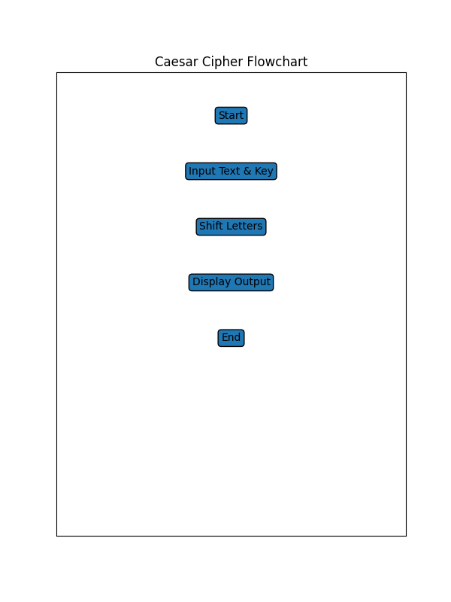

Screenshot
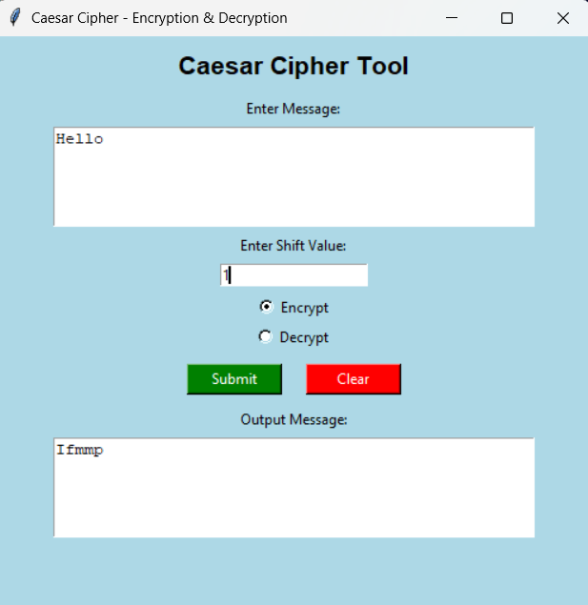
Source Code
# ---------------------------------------
# Caesar Cipher GUI (Encryption/Decryption)
# ---------------------------------------

import tkinter as tk
from tkinter import messagebox

# Caesar Cipher Function
def caesar_cipher(text, shift, mode):
result = ""
for char in text:
if char.isalpha():
ascii_base = ord('A') if char.isupper() else ord('a')
if mode == "encrypt":
shifted = (ord(char) - ascii_base + shift) % 26
else: # decrypt
shifted = (ord(char) - ascii_base - shift) % 26

result += chr(shifted + ascii_base)
else:
result += char
return result

# Process Button Function
def process_text():
text = input_text.get("1.0", tk.END).strip()
shift = shift_entry.get()
if not shift.isdigit():
messagebox.showerror("Error", "Shift must be a number!")
return
shift = int(shift)
if mode.get() == "Encrypt":
result = caesar_cipher(text, shift, "encrypt")
else:
result = caesar_cipher(text, shift, "decrypt")
output_text.delete("1.0", tk.END)
output_text.insert(tk.END, result)

def clear_all():
input_text.delete("1.0", tk.END)
output_text.delete("1.0", tk.END)
shift_entry.delete(0, tk.END)
mode.set("Encrypt") # Reset to default

# -----------------------
# GUI Design
# -----------------------

root = tk.Tk()
root.title("Caesar Cipher - Encryption & Decryption")
root.geometry("500x480")
root.configure(bg="lightblue")
title_label = tk.Label(root, text="Caesar Cipher Tool", font=("Arial", 16, "bold"), bg="lightblue")
title_label.pack(pady=10)

# Input Text
tk.Label(root, text="Enter Message:", bg="lightblue").pack()
input_text = tk.Text(root, height=5, width=50)
input_text.pack(pady=5)

# Shift Value
tk.Label(root, text="Enter Shift Value:", bg="lightblue").pack()
shift_entry = tk.Entry(root)
shift_entry.pack(pady=5)

# Mode Selection
mode = tk.StringVar(value="Encrypt")
tk.Radiobutton(root, text="Encrypt", variable=mode, value="Encrypt", bg="lightblue").pack()
tk.Radiobutton(root, text="Decrypt", variable=mode, value="Decrypt", bg="lightblue").pack()

# Buttons Frame
button_frame = tk.Frame(root, bg="lightblue")
button_frame.pack(pady=10)
process_button = tk.Button(button_frame, text="Submit", command=process_text, bg="green", fg="white", width=10)
process_button.grid(row=0, column=0, padx=10)
clear_button = tk.Button(button_frame, text="Clear", command=clear_all, bg="red", fg="white", width=10)
clear_button.grid(row=0, column=1, padx=10)

# Output Text
tk.Label(root, text="Output Message:", bg="lightblue").pack()
output_text = tk.Text(root, height=5, width=50)
output_text.pack(pady=5)
root.mainloop()

2. Playfair Cipher
Aim
To implement Playfair Cipher using Python GUI with matrix visualization.
Theory
Uses 5x5 matrix and digraph substitution technique.
Algorithm
1. Generate 5x5 matrix from key.
2. Prepare plaintext in pairs.
3. Apply Playfair rules.
4. Display result.
Flowchart

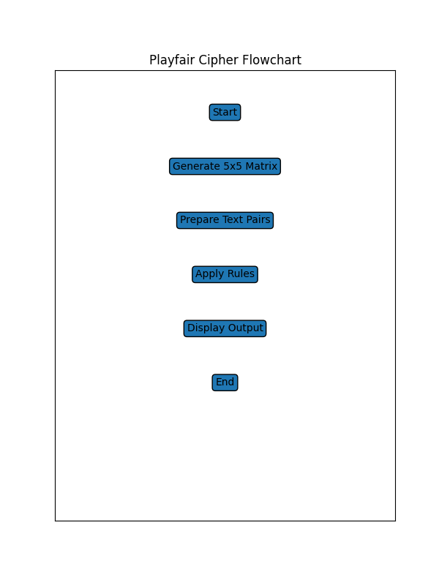

Screenshot
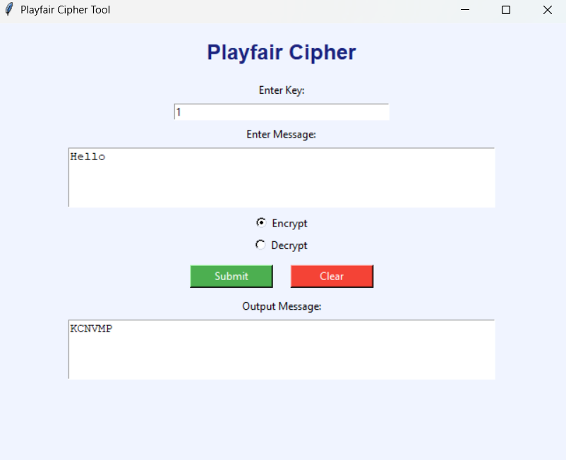
Source Code

import tkinter as tk
from tkinter import messagebox

# -------- Generate Matrix --------
def generate_matrix(key):
key = key.upper().replace("J", "I")
matrix = []
used = set()
for ch in key:
if ch.isalpha() and ch not in used:
matrix.append(ch)
used.add(ch)
for ch in "ABCDEFGHIKLMNOPQRSTUVWXYZ":
if ch not in used:
matrix.append(ch)
return [matrix[i:i+5] for i in range(0, 25, 5)]

# -------- Prepare Text --------
def prepare_text(text):
text = text.upper().replace("J", "I")
text = "".join(c for c in text if c.isalpha())
result = ""
i = 0
while i < len(text):
a = text[i]
if i+1 < len(text):
b = text[i+1]
if a == b:
result += a + "X"
i += 1
else:
result += a + b
i += 2
else:
result += a + "X"
i += 1
return result

# -------- Find Position --------
def find_pos(matrix, ch):
for r in range(5):
for c in range(5):
if matrix[r][c] == ch:
return r, c

# -------- Cipher --------
def playfair(text, key, mode):
matrix = generate_matrix(key)
if mode == "Encrypt":
text = prepare_text(text)
else:
text = text.upper().replace("J", "I")
text = "".join(c for c in text if c.isalpha())
result = ""
for i in range(0, len(text), 2):
a, b = text[i], text[i+1]
r1, c1 = find_pos(matrix, a)
r2, c2 = find_pos(matrix, b)
if r1 == r2:
if mode == "Encrypt":
result += matrix[r1][(c1+1)%5] + matrix[r2][(c2+1)%5]
else:
result += matrix[r1][(c1-1)%5] + matrix[r2][(c2-1)%5]
elif c1 == c2:
if mode == "Encrypt":
result += matrix[(r1+1)%5][c1] + matrix[(r2+1)%5][c2]
else:
result += matrix[(r1-1)%5][c1] + matrix[(r2-1)%5][c2]
else:
result += matrix[r1][c2] + matrix[r2][c1]
return result

# -------- Process --------
def process():
text = input_text.get("1.0", tk.END).strip()
key = key_entry.get().strip()
if not key:
messagebox.showerror("Error", "Enter key!")
return
result = playfair(text, key, mode.get())
output_text.delete("1.0", tk.END)
output_text.insert(tk.END, result)
def clear_all():
input_text.delete("1.0", tk.END)
output_text.delete("1.0", tk.END)
key_entry.delete(0, tk.END)
mode.set("Encrypt")

# -------- GUI --------

root = tk.Tk()
root.title("Playfair Cipher Tool")
root.geometry("650x500")
root.configure(bg="#f0f4ff") # Light background color
tk.Label(root,
text="Playfair Cipher",
font=("Arial", 18, "bold"),
bg="#f0f4ff",
fg="#1a237e").pack(pady=15)
tk.Label(root, text="Enter Key:",
bg="#f0f4ff").pack()
key_entry = tk.Entry(root, width=40)
key_entry.pack(pady=5)
tk.Label(root, text="Enter Message:",
bg="#f0f4ff").pack()

input_text = tk.Text(root, height=4, width=60)
input_text.pack(pady=5)
mode = tk.StringVar(value="Encrypt")
tk.Radiobutton(root, text="Encrypt",
variable=mode, value="Encrypt",
bg="#f0f4ff").pack()
tk.Radiobutton(root, text="Decrypt",
variable=mode, value="Decrypt",
bg="#f0f4ff").pack()
btn_frame = tk.Frame(root, bg="#f0f4ff")
btn_frame.pack(pady=10)
tk.Button(btn_frame,
text="Submit",
command=process,
bg="#4caf50",
fg="white",
width=12).grid(row=0, column=0, padx=10)
tk.Button(btn_frame,
text="Clear",
command=clear_all,
bg="#f44336",
fg="white",
width=12).grid(row=0, column=1, padx=10)
tk.Label(root,
text="Output Message:",
bg="#f0f4ff").pack()
output_text = tk.Text(root, height=4, width=60)
output_text.pack(pady=5)
root.mainloop()

3. Hill Cipher
Aim
To implement Hill Cipher using 2x2 matrix in Python GUI.
Theory
Encryption: C = K × P mod 26
Decryption: P = K⁻¹ × C mod 26
Algorithm
1. Input message and 2x2 key matrix.
2. Convert letters to numbers.
3. Multiply matrix mod 26.
4. Display output
Flowchart
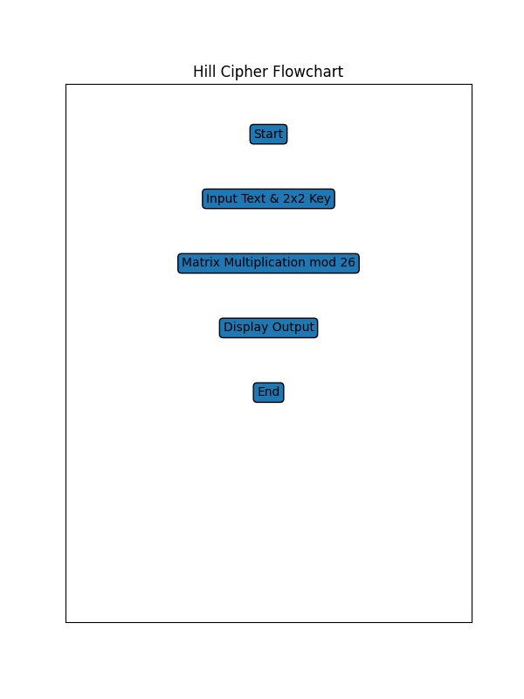

Screenshot
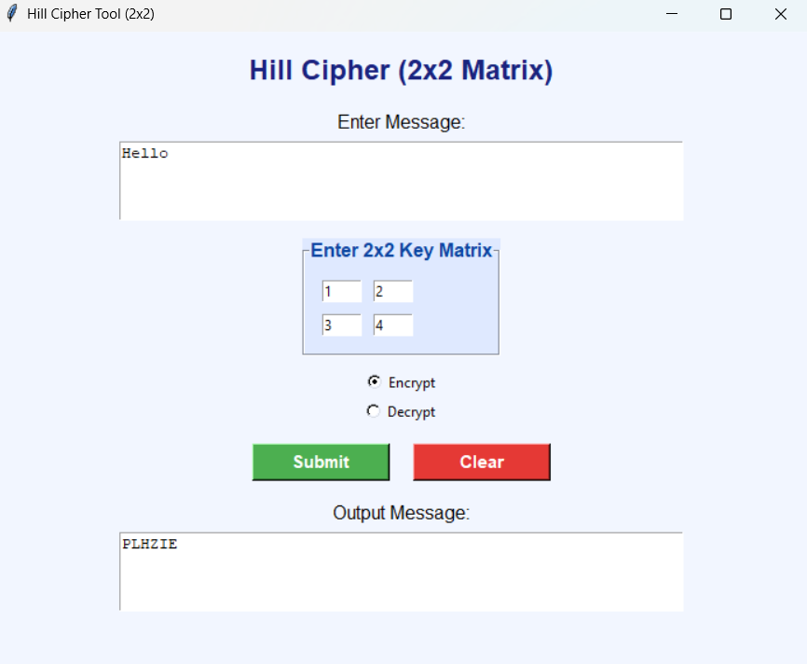
Source Code
import tkinter as tk
from tkinter import messagebox

# -------- Helper Functions --------

def char_to_num(c):
return ord(c) - ord('A')
def num_to_char(n):
return chr(n % 26 + ord('A'))
def prepare_text(text):
text = text.upper()
text = "".join([c for c in text if c.isalpha()])
if len(text) % 2 != 0:
text += "X"
return text

# -------- Matrix Operations --------

def multiply_matrix(key, vector):
return [
(key[0][0]*vector[0] + key[0][1]*vector[1]) % 26,
(key[1][0]*vector[0] + key[1][1]*vector[1]) % 26
]
def determinant(key):
return (key[0][0]*key[1][1] - key[0][1]*key[1][0]) % 26
def mod_inverse(det):
for i in range(1, 26):
if (det * i) % 26 == 1:
return i
return None
def inverse_matrix(key):
det = determinant(key)
inv_det = mod_inverse(det)
if inv_det is None:
return None
return [
[ key[1][1]*inv_det % 26, (-key[0][1]*inv_det) % 26],
[(-key[1][0]*inv_det) % 26, key[0][0]*inv_det % 26]
]

# -------- Hill Cipher --------

def hill_encrypt(text, key):
text = prepare_text(text)
result = ""
for i in range(0, len(text), 2):
vector = [char_to_num(text[i]), char_to_num(text[i+1])]
encrypted = multiply_matrix(key, vector)
result += num_to_char(encrypted[0]) + num_to_char(encrypted[1])
return result
def hill_decrypt(text, key):
inv_key = inverse_matrix(key)
if inv_key is None:
return None
text = prepare_text(text)
result = ""
for i in range(0, len(text), 2):
vector = [char_to_num(text[i]), char_to_num(text[i+1])]
decrypted = multiply_matrix(inv_key, vector)
result += num_to_char(decrypted[0]) + num_to_char(decrypted[1])
return result

# -------- GUI Functions --------

def process_text():
text = input_text.get("1.0", tk.END).strip()
try:
key = [
[int(k1.get()), int(k2.get())],
[int(k3.get()), int(k4.get())]
]
except:
messagebox.showerror("Error", "Enter valid key numbers!")
return
if mode.get() == "Encrypt":
result = hill_encrypt(text, key)
else:
result = hill_decrypt(text, key)
if result is None:
messagebox.showerror("Error", "Key matrix not invertible!")
return
output_text.delete("1.0", tk.END)
output_text.insert(tk.END, result)
def clear_all():
input_text.delete("1.0", tk.END)
output_text.delete("1.0", tk.END)
k1.delete(0, tk.END)
k2.delete(0, tk.END)
k3.delete(0, tk.END)
k4.delete(0, tk.END)
mode.set("Encrypt")

# -------- GUI Design --------

root = tk.Tk()
root.title("Hill Cipher Tool (2x2)")
root.geometry("700x550")
root.configure(bg="#f2f6ff") # Light background color
title = tk.Label(root,
text="Hill Cipher (2x2 Matrix)",
font=("Arial", 18, "bold"),
bg="#f2f6ff",
fg="#1a237e")
title.pack(pady=15)

# Input Section
tk.Label(root, text="Enter Message:",
bg="#f2f6ff", font=("Arial", 12)).pack()
input_text = tk.Text(root, height=4, width=60)
input_text.pack(pady=5)

# Key Frame (Colored)
key_frame = tk.LabelFrame(root,
text="Enter 2x2 Key Matrix",
font=("Arial", 12, "bold"),
bg="#dfe9ff",
fg="#0d47a1",
padx=10, pady=10)
key_frame.pack(pady=10)
k1 = tk.Entry(key_frame, width=5)
k2 = tk.Entry(key_frame, width=5)
k3 = tk.Entry(key_frame, width=5)
k4 = tk.Entry(key_frame, width=5)
k1.grid(row=0, column=0, padx=5, pady=5)
k2.grid(row=0, column=1, padx=5, pady=5)
k3.grid(row=1, column=0, padx=5, pady=5)
k4.grid(row=1, column=1, padx=5, pady=5)

# Mode
mode = tk.StringVar(value="Encrypt")
tk.Radiobutton(root, text="Encrypt",
variable=mode, value="Encrypt",
bg="#f2f6ff").pack()
tk.Radiobutton(root, text="Decrypt",
variable=mode, value="Decrypt",
bg="#f2f6ff").pack()

# Buttons (Colored)
btn_frame = tk.Frame(root, bg="#f2f6ff")
btn_frame.pack(pady=15)
submit_btn = tk.Button(btn_frame,
text="Submit",
command=process_text,
bg="#4caf50",
fg="white",
font=("Arial", 11, "bold"),
width=12)
submit_btn.grid(row=0, column=0, padx=10)
clear_btn = tk.Button(btn_frame,
text="Clear",
command=clear_all,
bg="#e53935",
fg="white",
font=("Arial", 11, "bold"),
width=12)
clear_btn.grid(row=0, column=1, padx=10)

# Output
tk.Label(root, text="Output Message:",
bg="#f2f6ff", font=("Arial", 12)).pack()

output_text = tk.Text(root, height=4, width=60)
output_text.pack(pady=5)

root.mainloop()

Conclusion
This lab assignment successfully demonstrates the implementation of Caesar, Playfair, and Hill Ciphers using Python GUI. The project covers substitution techniques, digraph encryption, matrix operations, and modular arithmetic in cryptography.

